Callum McLaughlin

  24678805 Digital design & production

Assignment one

# Digital Design and Production

## Assignment 1

### Task 1

The first task was to create a selection of initial designs for the main character of a fantasy game. Three sets of initial designs were required, and one had to be chosen as the final design for the character. A basic storyboard was also required, containing some basic animations for the final character. Krita, a free drawing software was used to create the character designs.

The initial idea was to follow an edo period theme and create a character with the appearance of a samurai but without the armour they are know for wearing in battle. Many source photos and different characters from other games, TV Shows and animation were researched and a few with characteristics of the character that was envisioned were chosen as reference. A large portion of the reference came from a character called “Roronoa Zoro” from the anime “One Piece”. He has a large build but wields 3 katanas, one in each hand and one in his mouth.

The vision for the character was to have them dual wield katanas and also hold both on side of their body rather than the usual one on each side. The character also has light robes as that of a samurai in plain clothes during the edo period. His hairstyle is messy, and he has a ponytail at the back which is tied high. He also wears a mask on his face and the idea is for the character to have terrible scars on his face that he covers up with a mask that he also uses to hide his identity.

In terms of having both of his sword on one side of his hip, the idea is that the character has a unique sword draw style for two swords where he draws both at the same time but from one side of his hip whereas in most cases, a dual wielding character will cross their arms and draw on sword from each side on their hip with the opposing hand. This was just a simple design idea that adds a bit more interest and uniqueness to the character.

The images below show some of the references used for the design of the character. The image on the fair left is the character “Zoro” from “One Piece” that I had mentioned earlier. Zoro’s build and clothing were mainly used as reference when designing the character his hair was also used as reference as the concept was for the character to have messy hair tied into a ponytail at the back. The second image is “Kakashi” from “Naruto”, another animated series. Kakashi was used as reference for the eyes and also the mask on the character. The final picture is one that was found online from concept art for a work in progress comic. This hairstyle was close to the one envisioned for the character all that was needed was to recreate it but messier/spiked like Zoro’s.

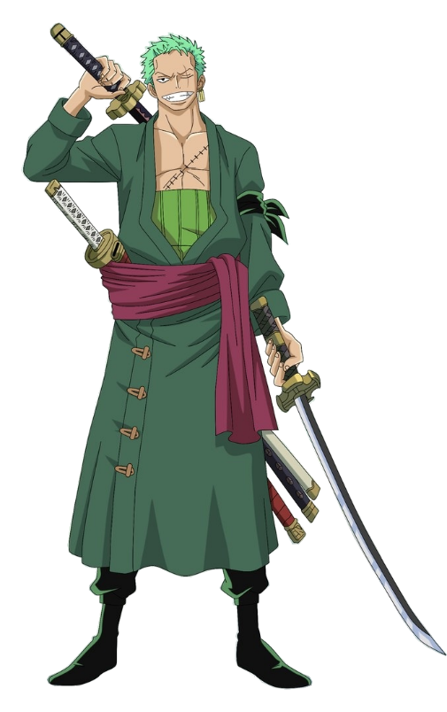

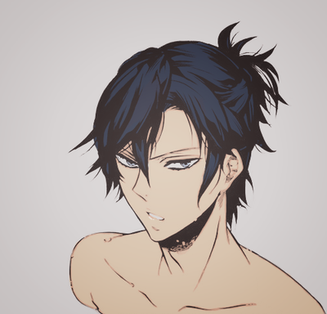

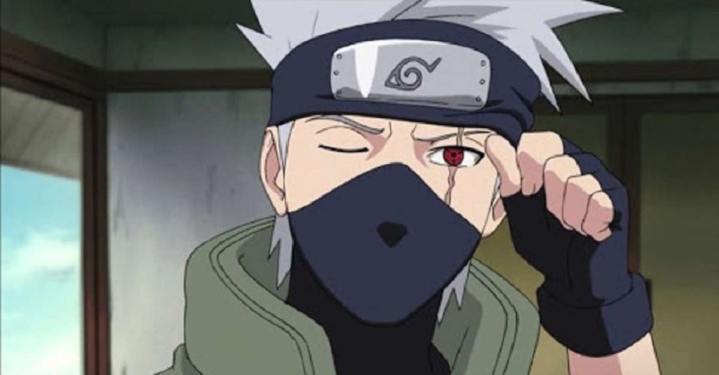

### Task 2

The second task was to create a building that follows one of the listed aesthetics detailed in the task brief. The building was to be complete and have all of the associated features. The 3D model would be created using blender. In order to decide the genre, research was necessary in order to see which buildings looked the most interesting and enjoyable to recreate. At first, Edo period seemed like the most interesting choice, however, after starting work on modelling an edo period Japanese fortress there were some complications, and a lot of the small details were far to intricate to be able to complete on time and without them the building would not have look complete. Instead the genre was changed to medieval and building a realistic castle was the new objective.

To start, extensive research was completed in order to come up with an initial idea and design. There were a number of real-world castles chosen as reference such as Bodiam castle, Warwick castle, Caernafon castle and also Conway castle, which would be the course of most of the reference and inspiration for the final design. These castles all have a similar design in that their towers look quite similar and follow the same pattern with open top towers with crenels around the tops of the towers.

It was decided that Conway castle would be used for most of the referencing for the towers and the layout of the other castles would determine where the towers would be placed, how frequently and where the windows could be placed in the towers. Only some of the towers had windows so it was decided to just use a few in the main towers and the main gate towers were also changed to be quite different from the other “watch towers”.

Below are some of the castles that were used for reference, from top left to bottom right are Caernarfon Castle in Wales, Warwick Castle in England, Bodiam Castle in England, and Conway Castle in Wales.

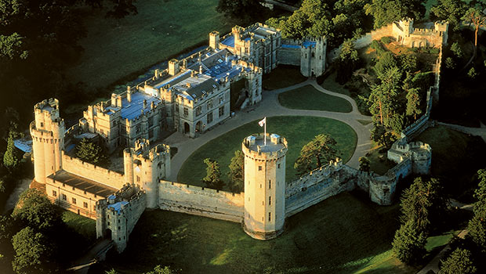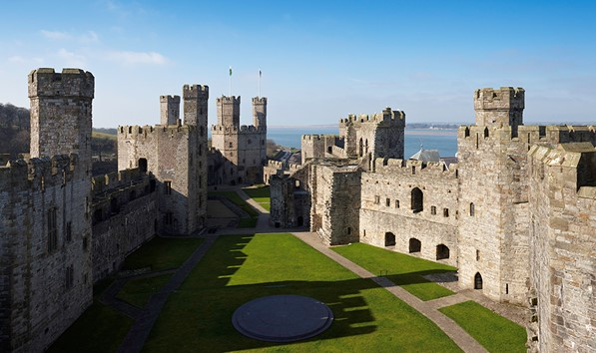

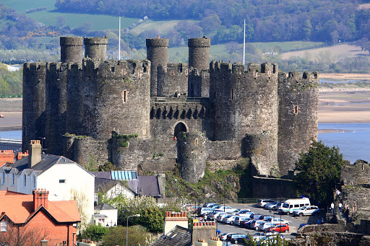

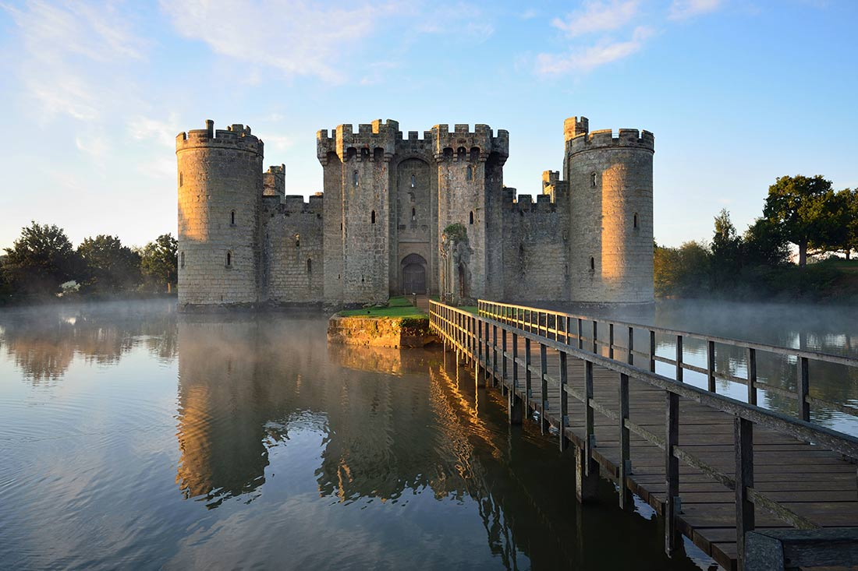

### Task 3

The third task was to create the character that was designed in Task 1, as 3D model in blender. A few problems were encountered during this task and it ended up taking a lot of effort just to get a basic model so the character model was not completely finished. Instead all the model is essentially is a basic outline of a human body with a sword on the hip of the character.

A number of different techniques were tried such as modelling using the mirror tool so that only one side of the body would have to be create for it to be automatically created symmetrically on the other side but there were some problems with this method also.

In the end the majority of the model was created using sculpting tools and apart from that there is not much to say on the rest of the design as the mode is very basic and lacking overall, but this was down to poor time management and underestimation of how long this task would take to complete.

An image of the completed model is shown below:

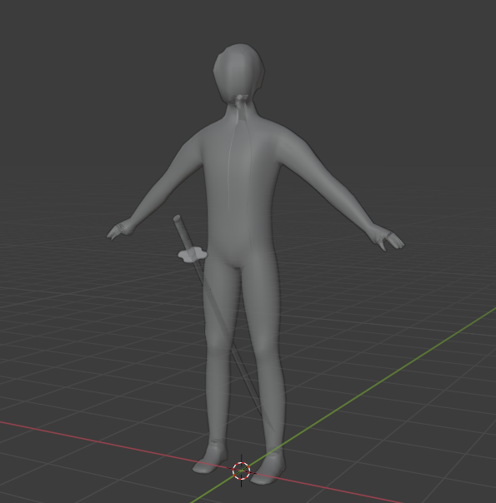

### Task 4

After completing task 3 the next task was to make use of the model that had just been created and create two separate animations for the character. The animations for the character would be a sword draw animation where the character would reach across their body with their left hand and draw their sword from the right side of their hip. The second animation would be an unarmed attack animation where the character would raise their fists and then punch a few times before lowering their fists.

In order to ensure that the animation looked as realistic as possible, some research was done on human anatomy and how the bones in the human body move with the ligaments and muscles. This felt necessary in order to create a convincing animation and to also ensure that any of the armatures on the character did not move in an unnatural way. A very useful video that can be found on YouTube gave insight and helped to understand how an animation can be improved and make the characters movements seem believable, Zendrin, (2017) “7 Tips for smoother Animation”.

An image of the rigged character, mid pose, can be seen below:

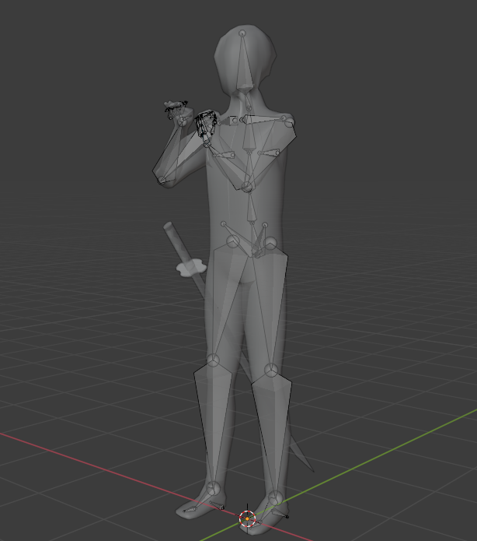

### Task 5

The final task was to develop a short script with at least two characters. The script includes a dialogue between the two characters and other factors that complete the scenes picture beyond actual words were also to be included, e.g. narration of body language and setting. The conversation was then to be recorded and it was also suggested that sound effects such as background noise and other effects be added to enhance the quality. The conversation was to last for around 5 minutes and a setting would need to be clear, e.g. time period and surroundings.

For this conversation, the idea was already there to stick with the Edo period as with the initial character design and it was decided that would be the main protagonist of the script. The setting would be edo period japan, where feudal lords still reigned over the country and the samurai still roamed the lands serving the emperor.

The two main characters are Takeshi Matsumoto and Lord Kenji Nakamura. Takeshi is a young man in his late twenties that has been on a path of vengeance for more than 20 years, training his whole life to kill the man that murdered his father. He is aimless and has no other aspirations aside from this, it has consumed him and his life. His will steadfast and he will not stop until he achieves his goal of revenge.

On the other hand, Lord Kenji Nakamura is a wicked feudal lord who reigns over his prefecture with an iron fist. He kills those who oppose him and takes what he wants from the people he is supposed to protect. He is sure of himself and believes that he is untouchable, he rarely is seen with guards as he is a renowned swordsman himself and rarely needs the protection of others. He killed Takeshis father over 20 years ago because he refused to give into the lords demands. Nakamura made an example of his father and killed him in front of his family. He only cares about status and power and will stop at nothing to further his greedy ambitions.

A lot of the ideas for setting and such were derived from a manga (Japanse Comic) called “Vagabond” which tells the story of Sinmen Takezou who runs away from his village in search of something grander than provincial life. Vagabond has a lot of different fight scenes that take place in a lot of different locations and they were good inspiration for the setting of the script,

## References

Zendrin, (2017) “7 Tips for smoother Animation” Available at: <https://youtu.be/yVcZXW80GKA> (Accessed 02/03/2021).

Takehiko Onoue, Vagabond Available at: <https://www.viz.com/vagabond> (Accessed 01/03/2021)

## Appendices

### Character designs

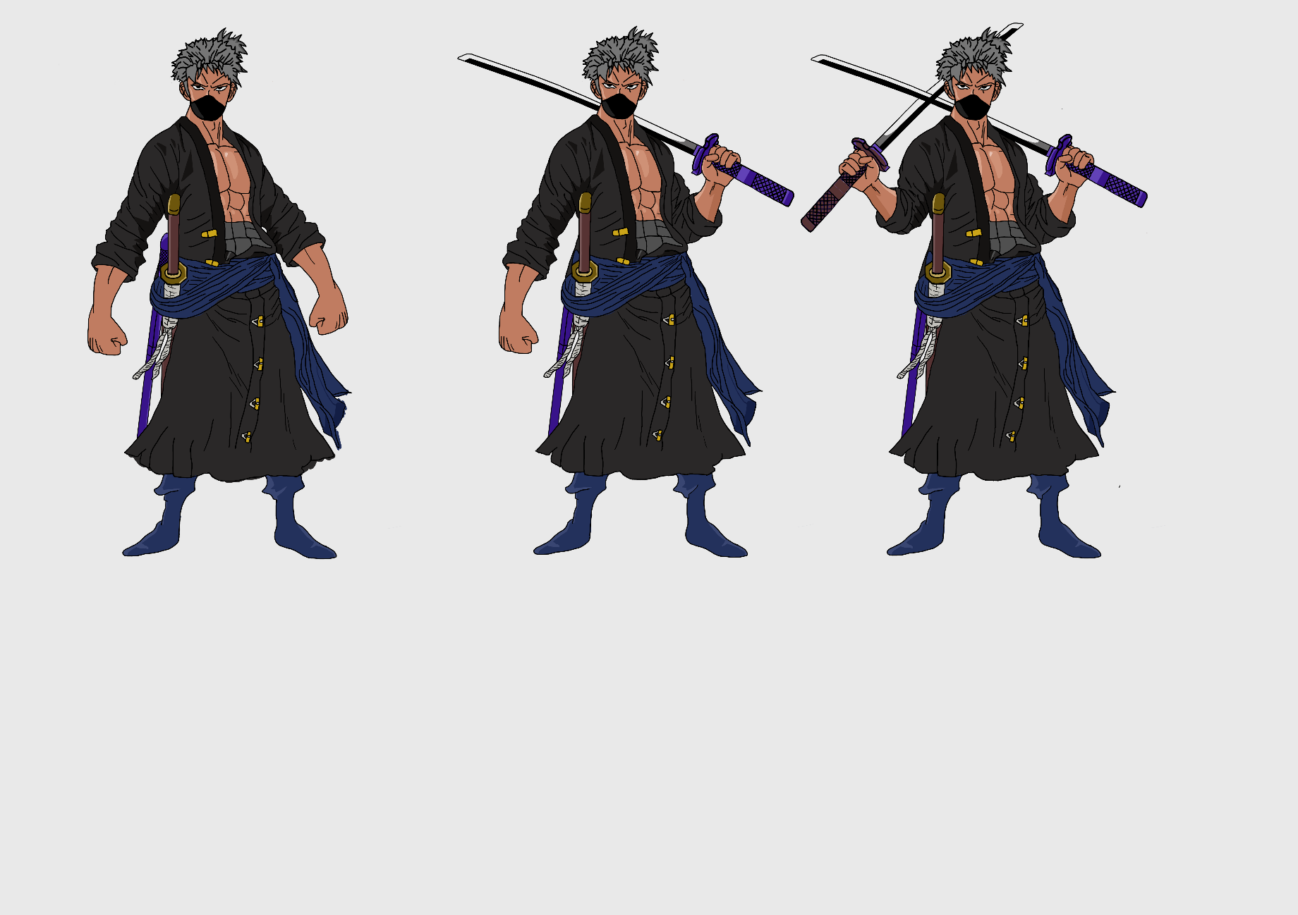

### Animation Storyboard

### 